Third-Party Application Security Assessment (TPASA)
OHDSI OMOP Pre-ETL Stage
Prepared by: | <<Creator Name>>
Approved by: | <<Approver Name>>
Creation Date: | <<Creation Date>>
Approval Date: | <<Approval Date>>
Version: | <<Version>>
Status | <<e.g., Draft>>

Table of Contents
1. Executive Summary 3
2. Tool Overview 3
3. Vendor / Source Information 4
4. Technical Architecture Review 4
5. Java Runtime & Dependency Assessment 5
6. Data Sensitivity Analysis 6
7. Security Risk Assessment Table 7
8. Verification Steps 8
9. Lifecycle and Maintenance 8
10. Alternatives Considered 8

- Executive Summary
Purpose
Request approval to whitelist White-Rabbit and Rabbit-In-a-Hat for use in the OMOP ETL pre-processing workflow.
Business Need
- Required for OMOP CDM ETL design
- Used only in controlled research environment
- No production data exposure outside secure environment

Risk Level

- Low (offline Java desktop tools)
- No network requirement
- No embedded update mechanisms

- Tool Overview
White-Rabbit
- Purpose: Source data profiling
- Platform: Java desktop application
- Input: CSV, flat files, database connections
- Output: Profiling statistics + scan report
Rabbit-In-a-Hat
- Purpose: ETL design documentation
- Platform: Java desktop application
- Input: Scan report
- Output: Mapping documentation

- Vendor / Source Information
Field | Value
Vendor | OHDSI Community (https://www.ohdsi.org/)
Governance | Open collaborative research network
License | Apache 2.0 (https://github.com/OHDSI/WhiteRabbit?tab=Apache-2.0-1-ov-file#readme)
Source Code | Public GitHub (https://github.com/OHDSI/WhiteRabbit)
Community | Academic + pharma + research institutions
Commercial Backing | Used by multiple global research networks
- Technical Architecture Review
Execution Model
- Standalone Java application
- No background services
- No daemon
- No auto-start
- No system-level privileges required
Network Behavior
- Does NOT require internet access
- Does NOT transmit data externally
- Does NOT auto-update
- No telemetry
Data Handling
- Reads local files or secure DB connections
- Writes local profiling reports
- No embedded cloud storage
- No external API calls

- Java Runtime & Dependency Assessment
Runtime Requirements
- Requires Java Runtime Environment (JRE) 8 or later
- No requirement for JDK
- Runs as user-level desktop application
- No elevated privileges required
- Not a digitally signed application.
Dependency Model
- Distributed as pre-built JAR files
- Does not download runtime dependencies dynamically
- No Maven/Gradle runtime resolution
- No auto-update mechanism

Top Level dependency for released v1.0.0 | Package(s)
 | ant-1.10.14.jar
 | ant-launcher-1.10.14.jar
 | avro-1.11.3.jar
 | checker-qual-3.42.0.jar
 | commons-codec-1.16.0.jar
 | commons-collections4-4.4.jar
 | commons-compress-1.26.0.jar
 | commons-csv-1.10.0.jar
 | commons-io-2.13.0.jar
 | commons-io-2.15.1.jar
 | commons-lang-2.6.jar
 | commons-lang3-3.14.0.jar
 | commons-logging-1.3.0.jar
 | commons-math3-3.6.1.jar
 | curvesapi-1.08.jar
 | dom4j-2.1.4.jar
 | hsqldb-2.7.2-jdk8.jar
 | httpclient-4.5.14.jar
 | httpcore-4.4.16.jar
 | jackcess-4.0.5.jar
 | jackson-annotations-2.14.2.jar
 | jackson-databind-2.14.2.jar
 | json-io-4.18.0.jar
 | log4j-api-2.20.0.jar
 | log4j-api-2.21.1.jar
 | log4j-core-2.21.1.jar
 | mysql-connector-j-8.3.0.jar
 | ojdbc8-19.23.0.0.jar
 | parso-2.0.14.jar
 | poi-5.2.4.jar
 | poi-excelant-5.2.4.jar
 | poi-ooxml-5.2.4.jar
 | poi-ooxml-lite-5.2.4.jar
 | poi-ooxml-lite-5.2.5.jar
 | postgresql-42.7.2.jar
 | protobuf-java-3.25.1.jar
 | rabbit-core-1.0.0.jar
 | rabbitinahat-1.0.0.jar
 | redshift-jdbc42-2.1.0.28.jar
 | slf4j-api-1.7.36.jar
 | slf4j-simple-1.7.36.jar
 | snowflake-jdbc-3.15.0.jar
 | SparseBitSet-1.3.jar
 | sqljdbc4-4.0.jar
 | streamex-0.8.2.jar
 | ucanaccess-5.0.1.jar
 | whiterabbit-1.0.0.jar
 | xmlbeans-5.2.0.jar

- Data Sensitivity Analysis
[Insert your source data classification level and other data sensitivity related aspects here.]

- Security Risk Assessment Table
Risk | Likelihood | Impact | Mitigation
Malware risk | Possible | Moderate | Follow the verification procedure.
Data exfiltration | Rare | Catastrophic | No network access allowed.
Dependency vulnerabilities | Likely | Moderate | No network access allowed.  Run regular dependency vulnerability checks.
Unauthorized access | Unlikely | Catastrophic | Run under restricted user account.

[Insert your organization risk scale here]
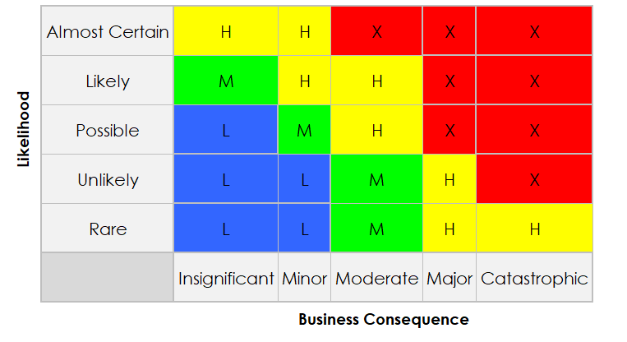

- Verification Steps
- Download only from official GitHub repository
- Verify SHA256 checksum
- Virus scan binary
- Restrict execution to research VM
- No internet access granted
- File integrity monitoring enabled

- Lifecycle and Maintenance
- Tool used only during ETL design phase
- Not part of production runtime
- No continuous background execution
- Version updates manually reviewed

- Alternatives Considered
- Manual profiling: inefficient
- Custom SQL profiling: time consuming
- Other commercial profiling tools: licensing costs

1.0 | 24/02/2026 | <<Name>> | Modified
Associated Documents
Document Name | Version | Date

